

Wrestlers Name: __________________________________________________________________________________

Address: _____________________________City:________________Zip:___________Phone:____________________

Email:___________________________________________ Grade 2014-15:_________________Weight:____________

School/Wrestling Club______________________________________________________________________________

T-Shirt Size(circle one) YS YM YL AS AM AL XL XXL **PREORDER A CCA WRESTLING SHIRT FOR AN ADDITIONAL $10** (ALL PREORDERS MUST BE RECEIVED BY OCTOBER 15TH) SHIRTS WILL ALSO BE AVAILABLE FOR PURCHASE AT THE CAMP WHILE SUPPLIES LAST. $15 EACH. **REGISTRATION AT THE DOOR WILL BE ACCEPTED.**

Session 1: 2nd-5th grade $40_______

Session 2: 6th-12th grade $40______

**SIBLING DISCOUNT-SECOND SIBLING $35 THIRD SIBLING $30 (FORMS MUST BE SENT IN TOGETHER)**

**MAKE CHECKS PAYABLE TO**: Clipper Youth Wrestling Club

**MAIL ENTRY FORMS TO**: Tara Scranton- 814 Croell Avenue, Tiffin, IA 52340

I certify that my child has been cleared by a physician and hereby grant my permission for my child to participate in any and all activities at the CCA Youth Wrestling Camp. I further waive any legal action against the CCA Youth Wrestling Camp and its technicians, CCA Youth Wrestling Club or any of their coaches/representatives and Clear Creek Amana School District and its employees for injuries my child may incur. I also grant permission to CCA Youth Wrestling Club to use photos/videos for promotional purposes.

Parents Name (printed)_______________________________________________________Date________________________

Parents Signature______________________________Emerg Contact #____________________________________________

Medical Concerns/Allergies_______________________________________________________________________________________

______________________________________________________________________________________________________



C:\Users\Scranton\Desktop\IAwrestle logo.jpg Elite Sports

**CLEAR CREEK AMANA PRE-SEASON WRESTLING CAMP (OPEN TO ALL EXPERIENCED WRESTLERS 2ND-12TH)**

**OCTOBER 26, 2014**

**CLEAR CREEK AMANA HIGH SCHOOL**

**551 W. Marengo Road Tiffin, IA 52340**

[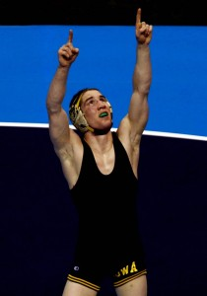](http://hawkcentral.com/2014/07/08/matt-mcdonough-medals-at-university-worlds/matt-mcdonough-university-worlds/)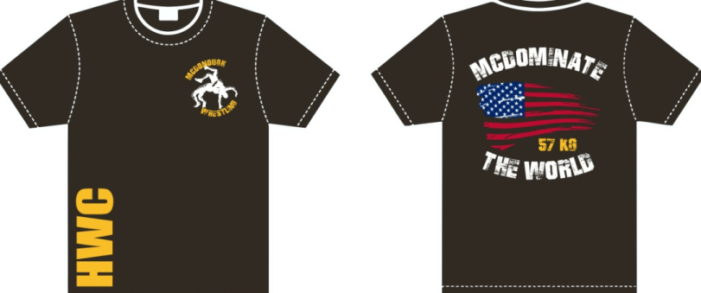

**FEATURING CAMP TECHNICIAN MATT MCDONOUGH!!**

**2X NCAA CHAMP**

**3X NCAA ALL-AMERICAN**

**2X BIG TEN CHAMP**

**NATIONAL TEAM MEMBER-2014**

**UNIVERSITY WORLD TEAM MEMBER-2014**

**3RD PLACE AT UNIVERSITY WORLD CHAMPIONSHIPS-2014**

MATT WILL HAVE HIS SHIRTS AVAILABLE FOR PURCHASE AT THE CAMP! YOUTH AND ADULT SIZES. ALL SHIRT PROCEEDS AND PART OF THE ENTRY FEE GO TOWARDS SUPPORTING MATTS TRAINING AND COMPETITION AT THE WORLD AND OLYMPIC LEVEL. ONLY $25 EACH!! **WHAT A GREAT WAY TO SHOW HIM OUR CCA SUPPORT!!**

**Camp Schedule OCTOBER 26, 2014**

9.15a-9.45a-CHECK IN SESSION 1

10a-12p-SESSION 1

12.15p-12.45p-CHECK IN SESSION 2

1p-3.30p-SESSION 2

**GOAL:** We are offering this preseason camp to get a jump on the 2014-2015 folkstyle wrestling season. During this camp we will be focusing on practicing technique, conditioning, and motivation. Matt will be having a Q&A session the last half an hour of each session along with time for autographs and pictures. Parents/Coaches are welcome to stay during the camp. **ANY QUESTIONS FEEL FREE TO EMAIL TARA AT**: [jtscranton@hotmail.com](mailto:jtscranton@hotmail.com) or call 319.471.0135